Seven-Pointed Star
# Source: AI Source: Provided by: [Data Path: Persons Table -> ID Column: 1, Name_En Column: Motasem Essam] -> From: [ChatGPT] on [7/25/2026]
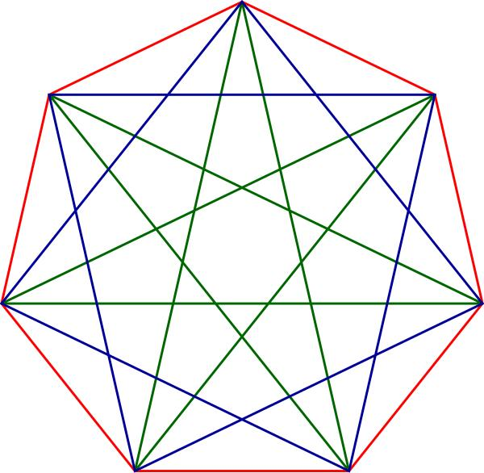
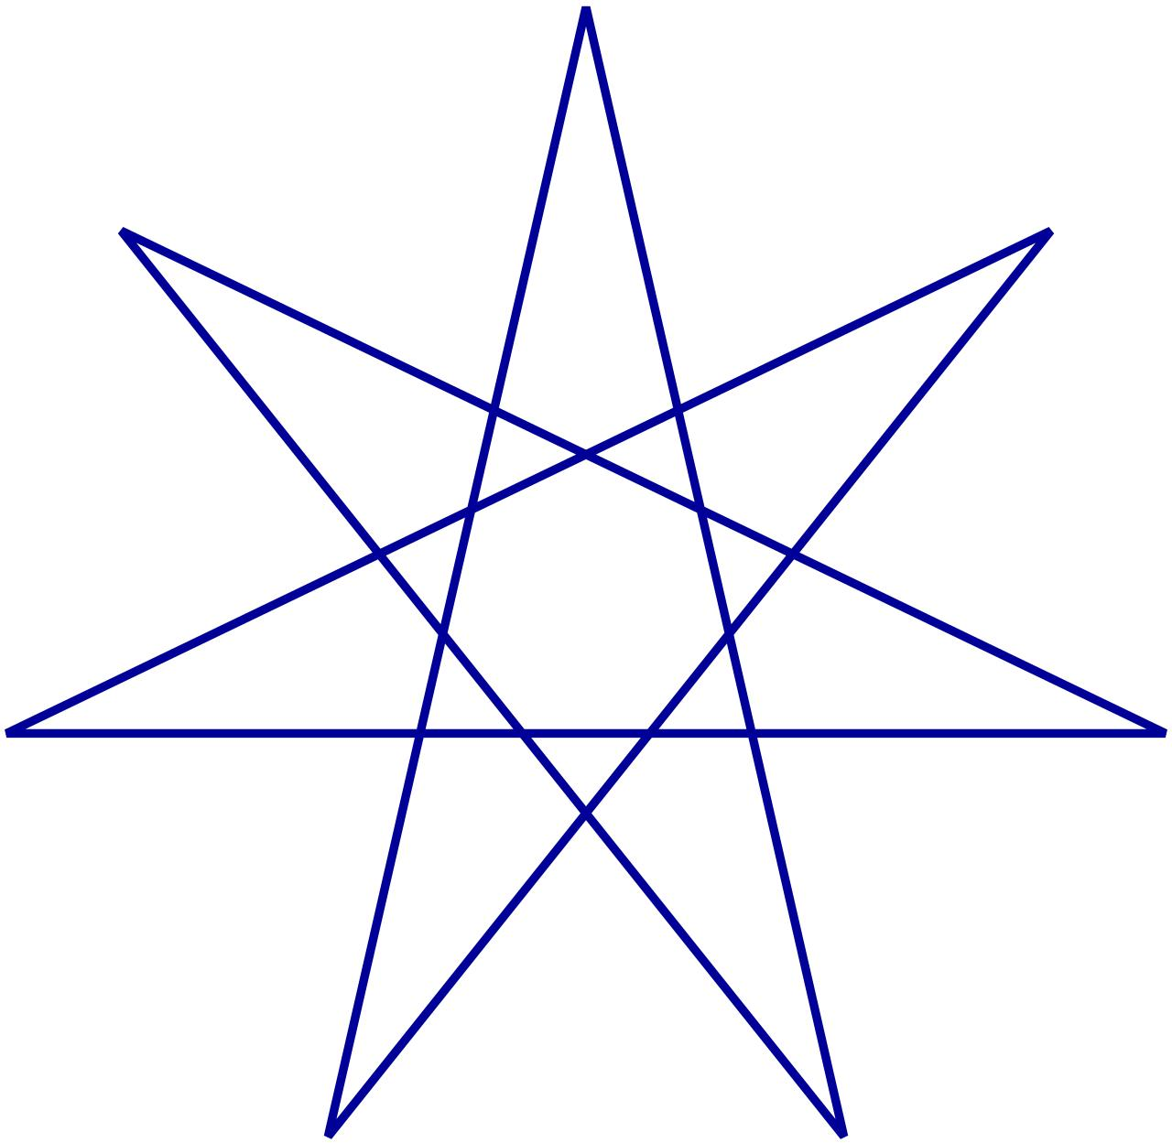
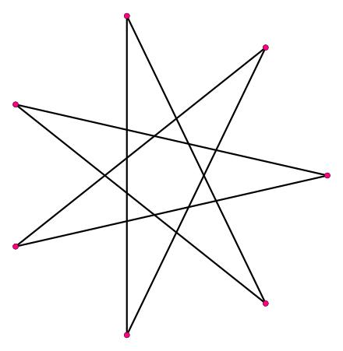
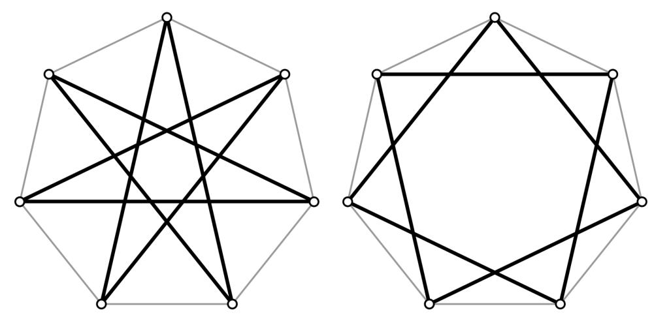

Definition
# Source: AI Source: Provided by: [Data Path: Persons Table -> ID Column: 1, Name_En Column: Motasem Essam] -> From: [ChatGPT] on [7/25/2026]
A Seven-Pointed Star is a star-shaped geometric figure with seven outer points.
When its boundary is formed by straight line segments that cross one another, it can be represented as a self-intersecting star polygon, called a heptagram.
A regular heptagram can be represented using Schläfli notation:
$$\left\{7/k\right\}$$
where:
- $7$= number of vertices of the underlying regular heptagon.
- $k$= step size, indicating how many vertices are skipped when connecting consecutive vertices.
The two principal regular heptagrams are:
$$\left\{7/2\right\}$$
and
$$\left\{7/3\right\}$$
Both produce seven-pointed star polygons, but their crossing patterns are different.

Purpose
# Source: AI Source: Provided by: [Data Path: Persons Table -> ID Column: 1, Name_En Column: Motasem Essam] -> From: [ChatGPT] on [7/25/2026]
The seven-pointed star is used to:
- Represent and study self-intersecting polygons.
- Demonstrate rotational and reflectional symmetry.
- Introduce regular star polygons.
- Study geometric constructions based on regular polygons.
- Explore angles, diagonals, intersections, and symmetry.
- Distinguish between ordinary polygons and self-intersecting polygons.

Fundamental Elements
# Source: AI Source: Provided by: [Data Path: Persons Table -> ID Column: 1, Name_En Column: Motasem Essam] -> From: [ChatGPT] on [7/25/2026]
A regular seven-pointed star has:
- 7 outer points.
- 7 principal vertices of the underlying regular heptagon.
- 7-fold rotational symmetry.
- 7 reflection axes for the regular form.
- Straight line segments forming the star boundary.
- Self-intersection points when represented as a heptagram.
- An underlying regular heptagon.
For a regular arrangement, the central rotational angle is:
$$\frac{{360}^{∘}}{7}≈{51.43}^{∘}$$
Thus, rotating the figure by approximately ${51.43}^{∘}$maps it onto itself.

Mathematical Representation

1. Regular Heptagram
# Source: AI Source: Provided by: [Data Path: Persons Table -> ID Column: 1, Name_En Column: Motasem Essam] -> From: [ChatGPT] on [7/25/2026]
The regular seven-pointed star polygons are represented as:
$$\left\{7/2\right\}$$
and
$$\left\{7/3\right\}$$

2. Vertex Construction
# Source: AI Source: Provided by: [Data Path: Persons Table -> ID Column: 1, Name_En Column: Motasem Essam] -> From: [ChatGPT] on [7/25/2026]
Start with a regular heptagon and label its vertices:
$$A,B,C,D,E,F,G$$
For $\left\{7/2\right\}$, connect every second vertex:
$$A→C→E→G→B→D→F→A$$
For $\left\{7/3\right\}$, connect every third vertex:
$$A→D→G→C→F→B→E→A$$
Because $7$is prime, both constructions visit all seven vertices before returning to the starting vertex.

Step Size
# Source: AI Source: Provided by: [Data Path: Persons Table -> ID Column: 1, Name_En Column: Motasem Essam] -> From: [ChatGPT] on [7/25/2026]
The value $k$ determines the connection pattern.
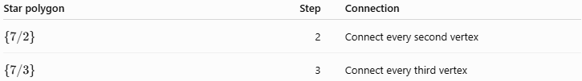
Star polygon | Step | Connection
$$\left\{7/2\right\}$$ | 2 | Connect every second vertex
$$\left\{7/3\right\}$$ | 3 | Connect every third vertex
The two are different heptagrams even though both have seven points.

Symmetry
# Source: AI Source: Provided by: [Data Path: Persons Table -> ID Column: 1, Name_En Column: Motasem Essam] -> From: [ChatGPT] on [7/25/2026]
A regular seven-pointed star has 7-fold rotational symmetry.
The smallest non-zero rotation that maps the figure onto itself is:
$$θ=\frac{{360}^{∘}}{7} \\ θ≈{51.43}^{∘}$$
It also has 7 lines of reflection symmetry when the star is constructed regularly.
Therefore, its symmetry can be summarized as:
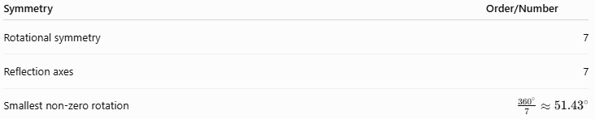
Symmetry | Order/Number
Rotational symmetry | 7
Reflection axes | 7
Smallest non-zero rotation | $$\frac{{360}^{∘}}{7}≈{51.43}^{∘}$$

Number of Edges
# Source: AI Source: Provided by: [Data Path: Persons Table -> ID Column: 1, Name_En Column: Motasem Essam] -> From: [ChatGPT] on [7/25/2026]
A regular heptagram has seven connecting edges in its star path:
$$P=7s$$
where $s$is the length of each star-path segment.
For example, if every star segment has length $4$cm:
$$P=7\left(4\right)=28\text{ cm}$$
Important: this is the length of the heptagram's seven drawn segments, not necessarily the perimeter of the outer filled star-shaped region.

Self-Intersection
# Source: AI Source: Provided by: [Data Path: Persons Table -> ID Column: 1, Name_En Column: Motasem Essam] -> From: [ChatGPT] on [7/25/2026]
Unlike a simple heptagon, a heptagram has edges that cross.
Therefore, it belongs to the category:
$$\text{Self-Intersecting Polygon}$$
and more specifically:
$$\text{Crossed Polygon}→\text{Crossed Star Polygon}→\text{Heptagram}$$
The intersections divide the star into multiple geometric regions.

Angles
# Source: AI Source: Provided by: [Data Path: Persons Table -> ID Column: 1, Name_En Column: Motasem Essam] -> From: [ChatGPT] on [7/25/2026]
The seven equally spaced vertices of the underlying regular heptagon divide a full rotation into:
$$\frac{{360}^{∘}}{7}≈{51.43}^{∘}$$
The exact angles inside the star depend on the particular heptagram construction, such as $\left\{7/2\right\}$or $\left\{7/3\right\}$.
Therefore, unlike the ordinary regular heptagon, it is not appropriate to automatically apply the ordinary polygon interior-angle formula to the self-intersecting star boundary.

Example 1: Seven-Pointed Star with Equal Edges
# Source: AI Source: Provided by: [Data Path: Persons Table -> ID Column: 1, Name_En Column: Motasem Essam] -> From: [ChatGPT] on [7/25/2026]
Suppose a regular heptagram has seven star-path segments, each $6$cm long.
Using:
$$P=7s$$
we get:
$$P=7\left(6\right) \\ \boxed{P=42\text{ cm}}$$

Example 2: Rotational Angle
# Source: AI Source: Provided by: [Data Path: Persons Table -> ID Column: 1, Name_En Column: Motasem Essam] -> From: [ChatGPT] on [7/25/2026]
Find the smallest positive rotation that maps a regular seven-pointed star onto itself.
$$θ=\frac{{360}^{∘}}{7}$$
Therefore:
$$\boxed{θ≈{51.43}^{∘}}$$

Example 3: Constructing $7/2$
# Source: AI Source: Provided by: [Data Path: Persons Table -> ID Column: 1, Name_En Column: Motasem Essam] -> From: [ChatGPT] on [7/25/2026]
Start with a regular heptagon:
$$A,B,C,D,E,F,G$$
Then connect:
$$A→C \\ C→E \\ E→G \\ G→B \\ B→D \\ D→F \\ F→A$$
The resulting figure is the regular heptagram:
$$\boxed{\left\{7/2\right\}}$$

Relationship with Related Concepts
# Source: AI Source: Provided by: [Data Path: Persons Table -> ID Column: 1, Name_En Column: Motasem Essam] -> From: [ChatGPT] on [7/25/2026]
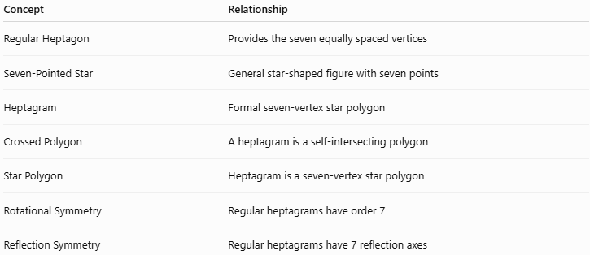
Concept | Relationship
Regular Heptagon | Provides the seven equally spaced vertices
Seven-Pointed Star | General star-shaped figure with seven points
Heptagram | Formal seven-vertex star polygon
Crossed Polygon | A heptagram is a self-intersecting polygon
Star Polygon | Heptagram is a seven-vertex star polygon
Rotational Symmetry | Regular heptagrams have order 7
Reflection Symmetry | Regular heptagrams have 7 reflection axes

Seven-Pointed Star vs Seven-Sided Polygon
# Source: AI Source: Provided by: [Data Path: Persons Table -> ID Column: 1, Name_En Column: Motasem Essam] -> From: [ChatGPT] on [7/25/2026]
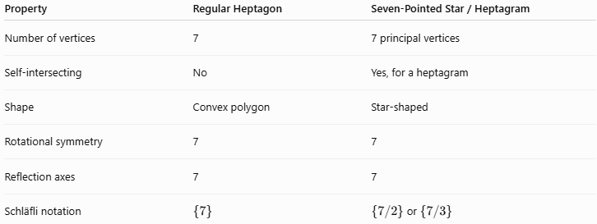
Property | Regular Heptagon | Seven-Pointed Star / Heptagram
Number of vertices | 7 | 7 principal vertices
Self-intersecting | No | Yes, for a heptagram
Shape | Convex polygon | Star-shaped
Rotational symmetry | 7 | 7
Reflection axes | 7 | 7
Schläfli notation | $$\left\{7\right\}$$ | $\left\{7/2\right\}$or $\left\{7/3\right\}$

Seven-Pointed Star vs Five-Pointed Star
# Source: AI Source: Provided by: [Data Path: Persons Table -> ID Column: 1, Name_En Column: Motasem Essam] -> From: [ChatGPT] on [7/25/2026]
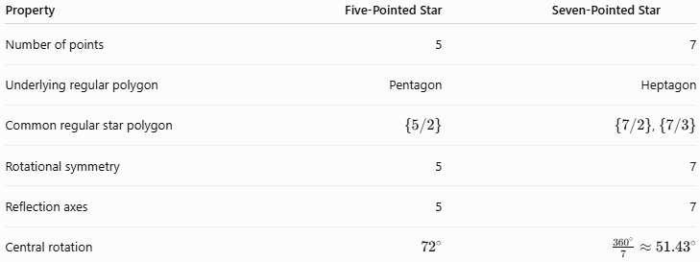
Property | Five-Pointed Star | Seven-Pointed Star
Number of points | 5 | 7
Underlying regular polygon | Pentagon | Heptagon
Common regular star polygon | $$\left\{5/2\right\}$$ | $\left\{7/2\right\}$, $\left\{7/3\right\}$
Rotational symmetry | 5 | 7
Reflection axes | 5 | 7
Central rotation | $${72}^{∘}$$ | $$\frac{{360}^{∘}}{7}≈{51.43}^{∘}$$

Taxonomy
# Source: AI Source: Provided by: [Data Path: Persons Table -> ID Column: 1, Name_En Column: Motasem Essam] -> From: [ChatGPT] on [7/25/2026]
For your Crossed Star Shapes hierarchy, I recommend:
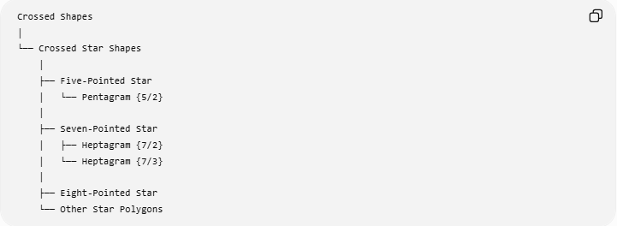
Crossed Shapes
│
└── Crossed Star Shapes
│
├── Five-Pointed Star
│ └── Pentagram {5/2}
│
├── Seven-Pointed Star
│ ├── Heptagram {7/2}
│ └── Heptagram {7/3}
│
├── Eight-Pointed Star
└── Other Star Polygons
More formally:
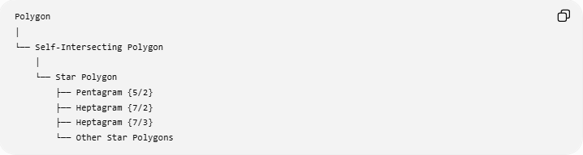
Polygon
│
└── Self-Intersecting Polygon
│
└── Star Polygon
├── Pentagram {5/2}
├── Heptagram {7/2}
├── Heptagram {7/3}
└── Other Star Polygons

Real-World Applications
# Source: AI Source: Provided by: [Data Path: Persons Table -> ID Column: 1, Name_En Column: Motasem Essam] -> From: [ChatGPT] on [7/25/2026]
Seven-pointed stars can appear in:
- Decorative geometric designs.
- Emblems and symbols.
- Artistic patterns.
- Architectural ornamentation.
- Textile and tile patterns.
- Mathematical illustrations.
- Symmetry studies.
- Computer-generated geometric graphics.

Advantages
# Source: AI Source: Provided by: [Data Path: Persons Table -> ID Column: 1, Name_En Column: Motasem Essam] -> From: [ChatGPT] on [7/25/2026]
- Demonstrates advanced polygon structures.
- Clearly illustrates rotational symmetry.
- Useful for studying self-intersection.
- Connects regular polygons with star polygons.
- Provides a practical introduction to Schläfli notation.

Limitations
- The term seven-pointed star is descriptive and does not always specify a unique mathematical construction.
- Different connection rules produce different heptagrams.
- Area calculations can become complicated because of self-intersections.
- Ordinary simple-polygon formulas cannot always be applied directly.
- The visual star symbol does not necessarily correspond to a formal heptagram.

Key Points
# Source: AI Source: Provided by: [Data Path: Persons Table -> ID Column: 1, Name_En Column: Motasem Essam] -> From: [ChatGPT] on [7/25/2026]
- A seven-pointed star has seven outer points.
- A formal self-intersecting seven-pointed star polygon is called a heptagram.
- The regular heptagrams include:
$$\boxed{\left\{7/2\right\}}$$
and
$$\boxed{\left\{7/3\right\}}$$
- A regular seven-pointed star has 7-fold rotational symmetry.
- Its smallest rotational angle is:
$$\boxed{\frac{{360}^{∘}}{7}≈{51.43}^{∘}}$$
- A regular heptagram has 7 reflection axes.
- It is a self-intersecting polygon.
- It belongs under Crossed Star Shapes → Star Polygons.

Conclusion
# Source: AI Source: Provided by: [Data Path: Persons Table -> ID Column: 1, Name_En Column: Motasem Essam] -> From: [ChatGPT] on [7/25/2026]
A Seven-Pointed Star is a seven-pointed star-shaped figure. When constructed by connecting the vertices of a regular heptagon in a non-consecutive pattern, it becomes a formal heptagram, principally represented by $\left\{7/2\right\}$or $\left\{7/3\right\}$. It is an important example of a self-intersecting star polygon, combining polygon construction, symmetry, angular relationships, and geometric intersections.

